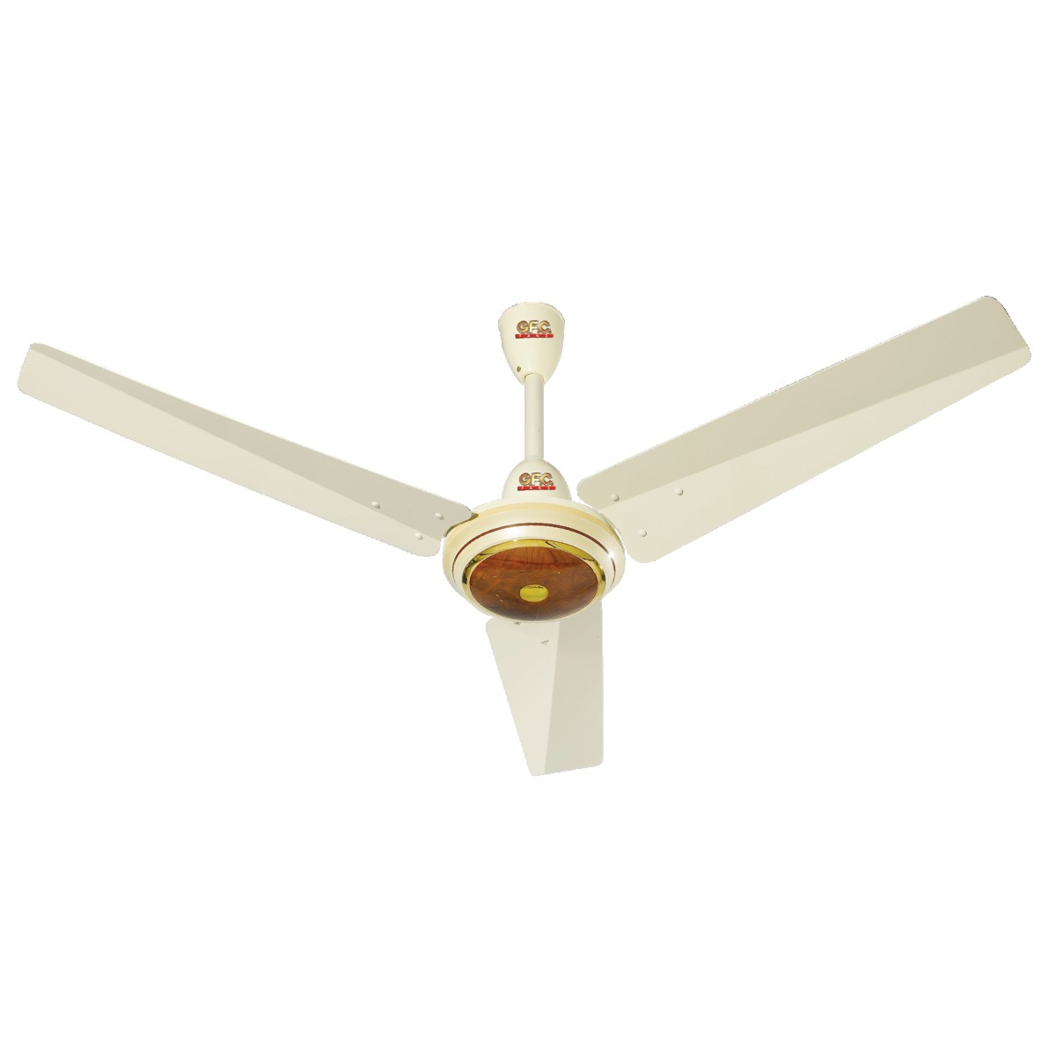

DW 270

* Brand Warranty
* Automatic Washing
* Washer & Spinner
* Sliver Color
* **Rs.39,199**